Use this as your guide for social media posting for the Purple Pinkie Donut Day 2023. You will find posts for specific days and specific social media channels. You just need to copy and paste to the appropriate social media channel.

If you have questions, contact Joe Stabb at jstabb@utk.edu.

September 12, 2023

Facebook

Preorders begin today! Take the #PurplePinkiePromise and start ordering your #PurplePinkieDonuts!
https://www.purplepinkiedonuts.org/

#endpolionow #rotary #peopleofaction

Instagram

Take the #PurplePinkiePromise and start ordering your #PurplePinkieDonuts! Use the link in the bio to order.

#endpolionow #rotary #peopleofaction

LinkedIn

Support #EndPolioNow and @RotaryInternational and take the #PurplePinkiePromise. Order your #PurplePinkieDonuts online at https://www.purplepinkiedonuts.org/.

Twitter

Preorders begin today! Take the #PurplePinkiePromise and start ordering your #PurplePinkieDonuts!
https://www.purplepinkiedonuts.org/

#endpolionow #rotary #peopleofaction

Graphic: 9-12_PPD.png
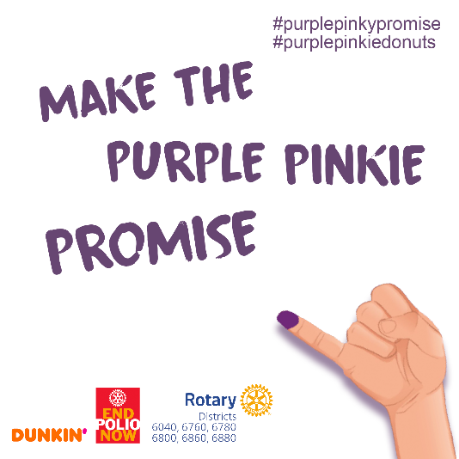
September 14, 2023

Facebook

Pre-order your @PurplePinkieDonuts before October 16. Every donation of $25 receives a box of 10 donuts!
https://www.purplepinkiedonuts.org/

Instagram

Pre-order your @PurplePinkieDonuts before October 16. Every donation of $25 receives a box of 10 donuts!

Carousel of images:
9-14_PPD-1.png
9-14_PPD-2.png
9-14_PPD-3.png
9-14_PPD-4.png

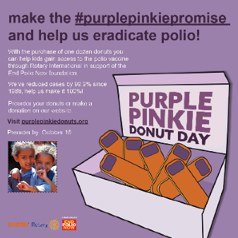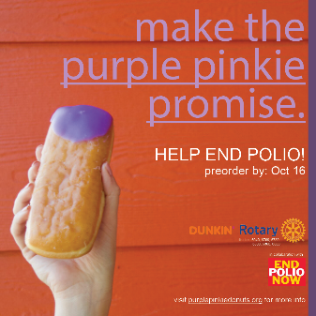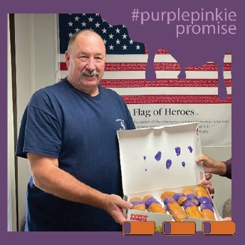

September 18, 2023

Facebook

Help fight Polio! Get your #PurplePinkieDonuts today!
https://www.purplepinkiedonuts.org/

Instagram

Help fight Polio! Get your #PurplePinkieDonuts today! Find the link to order in the bio.

Twitter

Help fight Polio! Get your #PurplePinkieDonuts today! https://www.purplepinkiedonuts.org/

Graphic: 9-18_PPD.png
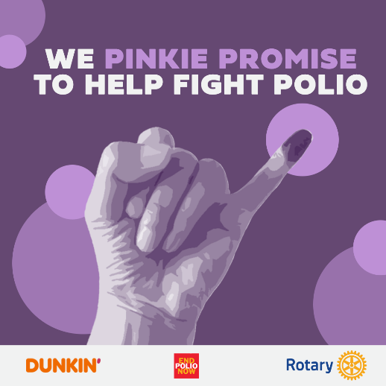

September 20, 2023

Facebook

Your $25 donation becomes $187.50 in the global fight to eradicate polio and on top of that you get a free box of #PurplePinkieDonuts as a thank you. Order today at https://www.purplepinkiedonuts.org/.

Instagram

Your $25 donation becomes $187.50 in the global fight to eradicate polio and on top of that you get a free box of #PurplePinkieDonuts as a thank you. Order today!

Graphic: 9-20_PPD.png

September 26, 2023

Note, there is different content for different locations for today. Make sure you are using the correct text for your donut day.

Facebook

TN/MS – #PurplePinkieDonutDay is October 25! Order your #PurplePinkieDonuts by October 16! 100% of your $25 donation goes to #EndPolioNow. https://www.purplepinkiedonuts.org/

AL - #PurplePinkieDonutDay is October 24! Order your #PurplePinkieDonuts by October 16! 100% of your $25 donation goes to #EndPolioNow. https://www.purplepinkiedonuts.org/

Instagram

TN/MS – #PurplePinkieDonutDay is October 25! Order your #PurplePinkieDonuts by October 16! 100% of your $25 donation goes to #EndPolioNow. Click the link in the bio.

AL - #PurplePinkieDonutDay is October 24! Order your #PurplePinkieDonuts by October 16! 100% of your $25 donation goes to #EndPolioNow. Click the link in the bio.

Twitter

TN/MS – #PurplePinkieDonutDay is October 25! Order your #PurplePinkieDonuts by October 16! 100% of your $25 donation goes to #EndPolioNow. https://www.purplepinkiedonuts.org/

AL - #PurplePinkieDonutDay is October 24! Order your #PurplePinkieDonuts by October 16! 100% of your $25 donation goes to #EndPolioNow. https://www.purplepinkiedonuts.org/

Graphic: 9-26_PPD.png

September 28, 2023

Facebook

Rotarians who donate to the “Raise for Rotary” fundraiser by October 24, (World Polio Day) will activate matching funds as part of the #PurplePinkieDonut campaign and will receive Paul Harris credit directly for their donation. https://www.purplepinkiedonuts.org/

#rotary #peopleofaction #serviceaboveself #endpolionow

Instagram

Rotarians who donate to the “Raise for Rotary” fundraiser by October 24, (World Polio Day) will activate matching funds as part of the #PurplePinkieDonut campaign and will receive Paul Harris credit directly for their donation. Click the link in the bio.

#rotary #peopleofaction #serviceaboveself #endpolionow

Twitter

Rotarians who donate to the “Raise for Rotary” fundraiser by October 24, (World Polio Day) will activate matching funds as part of the #PurplePinkieDonut campaign and will receive Paul Harris credit directly for their donation. https://www.purplepinkiedonuts.org/

#rotary #peopleofaction #serviceaboveself #endpolionow

Graphic: 9-28_PPD.png

October 2, 2023

Facebook

Order your #PurplePinkieDonuts before October 16. For each $25 donation you will receive 10 #PurplePinkieDonuts. Make a donation online at https://www.purplepinkiedonuts.org/.

Instagram

Order your #PurplePinkieDonuts before October 16. For each $25 donation you will receive 10 #PurplePinkieDonuts. Make a donation at the link in the bio.

Twitter

Order your #PurplePinkieDonuts before October 16. For each $25 donation you will receive 10 #PurplePinkieDonuts. Make a donation online at https://www.purplepinkiedonuts.org/.

Graphic: 10-2_PPD.jpg
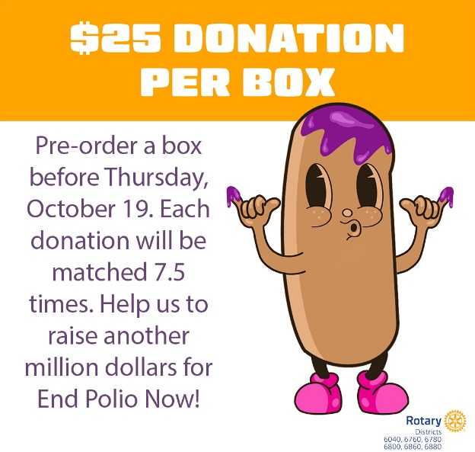

October 4, 2023

Facebook

Over the last 5 years we have raised just under $5 Million for the eradication of polio and our goal is to add another $1.5 Million this year. Make your $25 donation to support #EndPolioNow! https://www.purplepinkiedonuts.org/

Instagram

Over the last 5 years we have raised just under $5 Million for the eradication of polio and our goal is to add another $1.5 Million this year. Make your $25 donation to support #EndPolioNow!

Twitter

Over the last 5 years we have raised just under $5 Million for the eradication of polio and our goal is to add another $1.5 Million this year. Make your $25 donation to support #EndPolioNow! https://www.purplepinkiedonuts.org/

Graphic: 10-4_PPD.png

October 10, 2023

Facebook

One week left to donate and receive #PurplePinkieDonut. Make your donation today! https://www.purplepinkiedonuts.org/

#endpolionow #rotary

Instagram

One week left to donate and receive #PurplePinkieDonut. Make your donation today! Link in bio!

#endpolionow #rotary

Twitter

One week left to donate and receive #PurplePinkieDonut. Make your donation today! https://www.purplepinkiedonuts.org/

#endpolionow #rotary

Graphic: 10-10_PPD.png
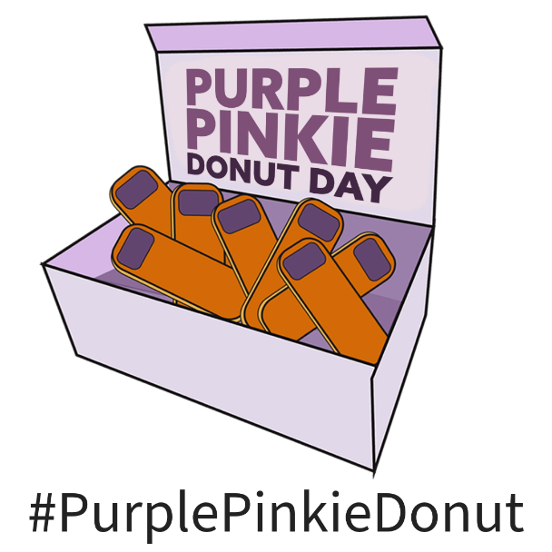

October 12, 2023

Facebook

Monday, October 16, is the last day to donate and receive your box of #PurplePinkieDonut. Donate before it is too late! Four days left! https://www.purplepinkiedonuts.org/

#endpolionow #rotary #peopleofservice

Instagram

Monday, October 16, is the last day to donate and receive your box of #PurplePinkieDonut. Donate before it is too late! Four days left! Click the link in the bio.

#endpolionow #rotary #peopleofservice

Twitter

Monday, October 16, is the last day to donate and receive your box of #PurplePinkieDonut. Donate before it is too late! Four days left! https://www.purplepinkiedonuts.org/

#endpolionow #rotary #peopleofservice

Graphic: 10-12_PPD.png

October 16, 2023

Facebook

Today is the last day to donate and receive a box of #PurplePinkieDonut! https://www.purplepinkiedonuts.org/

Instagram

Today is the last day to donate and receive a box of #PurplePinkieDonut! Click the link in the bio!

Twitter

Today is the last day to donate and receive a box of #PurplePinkieDonut! https://www.purplepinkiedonuts.org/

LinkedIn

Today is the last day to donate and receive a box of #PurplePinkieDonut! https://www.purplepinkiedonuts.org/

Graphic: 10-26_PPD.png

October 19, 2023

Facebook

You can still donate to support #PurplePinkieDay and #EndPolioNow! Raise for #Rotary to help us eradicate polio.
https://raise.rotary.org/PurplePinkieDonuts/fundraiser328

#peopleofservice

Graphic: No graphic

October 23, 2023

Note…posts for Alabama only!

Facebook

Tomorrow is #PurplePinkieDay! Don’t forget to pick up your #PurplePinkieDonut!

Instagram

Tomorrow is #PurplePinkieDay! Don’t forget to pick up your #PurplePinkieDonut!

Twitter

Tomorrow is #PurplePinkieDay! Don’t forget to pick up your #PurplePinkieDonut!

Graphic: 10-25_PPD.png

October 24, 2023

Note…posts for Alabama only!

Facebook

Today is #PurplePinkieDay! Don’t forget to pick up your #PurplePinkieDonut!

Instagram

Today is #PurplePinkieDay! Don’t forget to pick up your #PurplePinkieDonut!

Twitter

Today is #PurplePinkieDay! Don’t forget to pick up your #PurplePinkieDonut!

Graphic: 10-25_PPD.png

October 24, 2023

Note…posts for Tennessee only!

Facebook

Tomorrow is #PurplePinkieDay! Don’t forget to pick up your #PurplePinkieDonut!

Instagram

Tomorrow is #PurplePinkieDay! Don’t forget to pick up your #PurplePinkieDonut!

Twitter

Tomorrow is #PurplePinkieDay! Don’t forget to pick up your #PurplePinkieDonut!

Graphic: 10-25_PPD.png

October 25, 2023

Note…posts for Tennessee only!

Facebook

Today is #PurplePinkieDay! Don’t forget to pick up your #PurplePinkieDonut!

Instagram

Today is #PurplePinkieDay! Don’t forget to pick up your #PurplePinkieDonut!

Twitter

Today is #PurplePinkieDay! Don’t forget to pick up your #PurplePinkieDonut!

Graphic: 10-25_PPD.png

